Hierarchy security Model:

The hierarchy security model is an extension to the existing Microsoft Dynamics 365 security models that use business units, security roles, sharing, and teams. It can be used in conjunction with all other existing security models. The hierarchy security offers a more granular access to records for an organization and helps to bring the maintenance costs down. For example, in complex scenarios, you can start with creating several business units and then add the hierarchy security. This will achieve a more granular access to data with far less maintenance costs that a large number of business units may require.
Two security models can be used for hierarchies, the Manager hierarchy and the Position hierarchy. With the Manager hierarchy, a manager must be within the same business unit as the report, or in the parent business unit of the report’s business unit, to have access to the report’s data. The Position hierarchy allows data access across business units. If you are a financial organization, you may prefer the Manager Hierarchy model, to prevent managers’ accessing data outside of their business units. However, if you are a part of a customer service organization and want the managers to access service cases handled in different business units, the Position hierarchy may work better for you.

Manager hierarchy

The Manager Hierarchy security model is based on the management chain or direct reporting structure, where the manager’s and the report’s relationship is established by using the Manager Field on the system user entity. With this security model, the managers are able to access the data that their reports have access to. They are able to perform work on behalf of their direct reports or access information that needs approval
Note: With the Manager Hierarchy security model, a manager has access to the records owned by the user or by the team that a user is a member of, and to the records that are directly shared with the user or the team that a user is a member of.
In addition to the Manager Hierarchy security model, a manager must have at least the user level Read privilege on an entity, to see the reports’ data. For example, if a manager doesn’t have the Read access to the Case entity, the manager won’t be able to see the cases that their reports have access to
For a non-direct report, a manager has the Read-only access to the report’s data.
E.g.: If A (Manager) has two people under him like B and C.
A can see the record of B (direct report) and has Read, Write, Update, Append, Append to access to the report’s data. But he can only have Read-only access to C (non-direct report) reports or data.
This happens in Manager Hierarchy.
For a direct report, the manager has the Read, Write, Update, Append, Append to access to the report’s data.

Position hierarchy

The Position hierarchy is not based on the direct reporting structure, like the Manager hierarchy. A user doesn’t have to be an actual manager of another user to access user’s data. As an administrator, you will define various job positions in the organization and arrange them in the Position hierarchy. Then, you add users to any given position, or, as we also say, “tag” a user with a particular position. A user can be tagged only with one position in a given hierarchy, however, a position can be used for multiple users. Users at the higher positions in the hierarchy have access to the data of the users at the lower positions, in the direct ancestor path. The direct higher positions have Read, Write, Update, Append, Append to access to the lower positions’ data in the direct ancestor path. The non-direct higher positions, have Read-only access to the lower positions’ data in the direct ancestor path

Note:
With the Position hierarchy security, a user at a higher position has access to the records owned by a lower position user or by the team that a user is a member of, and to the records that are directly shared to the user or the team that a user is a member of.
In addition to the Position hierarchy security model, the users at a higher level must have at least the user level Read privilege on an entity to see the records that the users at the lower positions have access to. For example, if a user at a higher level doesn’t have the Read access to the Case entity, that user won’t be able to see the cases that the users at a lower positions have access to.

Important: To add a user to a position or change the user’s position, you must have the Assign position for a user privilege.

Below I have explained some brief and important points about the Hierarchy Security.
- It is an extension of the Dynamics CRM Security Model.
- It offers more granular access to records.
- It reduces maintenance costs, because it is easy to maintain and does not require a large number of Business Units.
Basically Hierarchy Security is divided into two parts.
- Manager hierarchy
- Position hierarchy

Important points about Manager Hierarchy
- Based on the direct reporting security model.
- This is established based on the Manager Field of the System user.
- Managers are able to access the data of their subordinates. And able to perform work on behalf of them.
- A manager must have at least the user level Read privilege on an entity, to see the data of their subordinates.
- Only restricted to the BU.

Important points about Position hierarchy
- Not based on direct reporting structure, as Manager Hierarchy.
- We can define various Job Positions & arrange Position hierarchy based on that Position. It means users at a higher position can access the data of lower positions.
- The direct higher positions must have Read, Write, Update, Append, Append to access to the lower positions data in the direct ancestor path. The non-direct higher positions, have Read-only access to the lower positions.
- Not restricted to the BU.
- With the Position hierarchy security, a user at a higher position can access records owned by a lower position user or by the team that a user is a member of.
- In addition to the Position hierarchy security model, the users at a higher level must have at least the user level Read privilege on an entity to see the records that the users at the lower positions have access to.

The Position hierarchy is *not* based on the direct reporting structure, like the Manager hierarchy. A user doesn’t have to be an actual manager of another user to access user’s data.

But based on the position, higher position’s user can access the data of the lower position’s users.
Example:
Let us enable Hierarchy Modelling and set the Hierarchy Depth as 2.
With depth we can specify up to what level the user can have read access to the records. Here the user will have write, update, append, append to access to those records only which are accessible to his direct report.

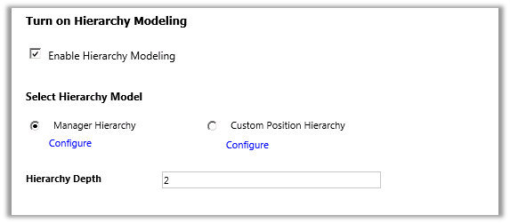
Let us say we have 3 users in our system.
- User A, Manager A and CEO.
- CEO is manager of Manager A and Manager A is manager of User A in our system.
- CEO → manager → Manager A → manager → User A
- User A is sales person and creates a contact record.
- Now in our configuration we have set depth as 2 which means.
- CEO user will have Write access to record that are accessible to Manager A and Read Access to those records accessible to User A.
- CEO opens a record created by User A. ( it is read only for him)

Performance considerations

To boost the performance, we recommend:
- Keep the effective hierarchy security to 50 users or less under a manager/position. Your hierarchy may have more than 50 users under a manager/position, but you can use the Depth setting to reduce the number of levels for Read-only access and with this limit the effective number of users under a manager/position to 50 users or less.
- Use hierarchy security models in conjunction with other existing security models for more complex scenarios. Avoid creating a large number of business units, instead, create fewer business units and add hierarchy security.
This feature helps us with giving permissions to managers to see their reporting resources records as needed.

This feature basically visualize the parent-child relationship records in to a beautiful visualization instead of viewing in a flat list of records. Which you can have its benefit out of the box without additional cost.

Under which cases we need to use hierarchy or position, provide your suggestions with an example..?
The major difference between Manager and position is business unit. Manager hierarchy deals when you are in same business unit, where position hierarchy deals with different business units.
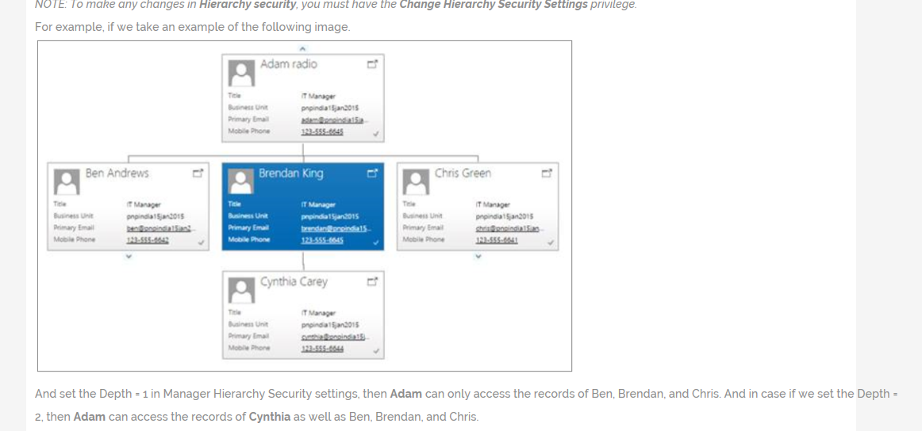
And set the Depth = 1 in Manager Hierarchy Security settings, then Adam can only access the records of Ben, Brendan, and Chris. And in case if we set the Depth = 2, then Adam can access the records of Cynthia as well as Ben, Brendan, and Chris.

